1. Select Look and Feel at the top of your survey

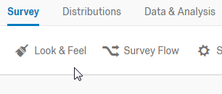

1. Select Advanced, then Edit the Footer

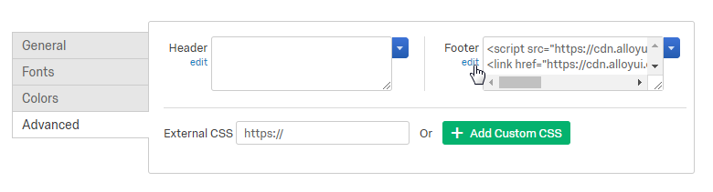

1. Click Source, then paste the following (copy and paste the text below the screenshot).

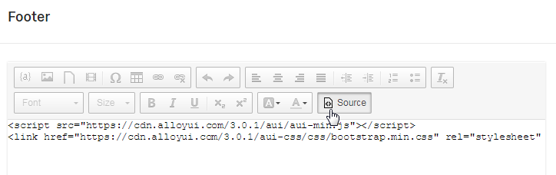

*<script src="https://cdn.alloyui.com/3.0.1/aui/aui-min.js"></script>*

*<link href="https://cdn.alloyui.com/3.0.1/aui-css/css/bootstrap.min.css" rel="stylesheet" />*

1. Save your changes.

For the first question: In the last 6 weeks, select the days when you had sex

1. Create a new question and set the Question Type to **Text Entry**
2. Click on the title and go to the **HTML View** tab

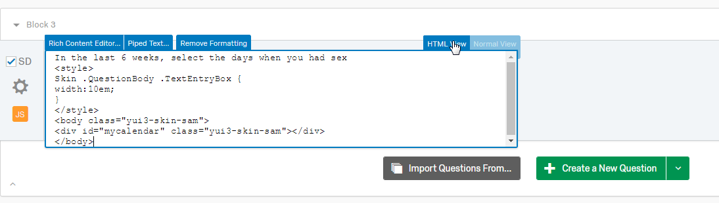

1. Clear the box, and paste this in:

*In the last 6 weeks, select the days when you had sex*

*<div id="mycalendar" class="yui3-skin-sam"></div>*

1. Select the COG icon on the question, and select **Add JavaScript…**

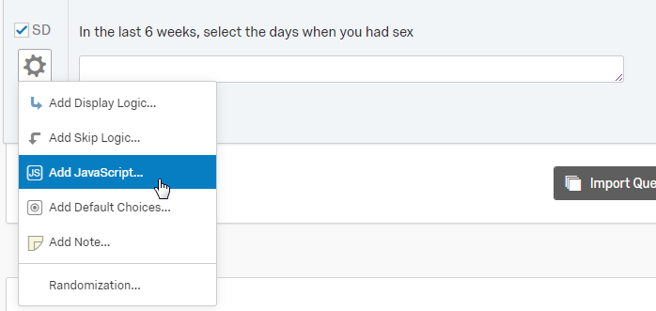

1. Clear the box and paste in this JavaScript

*Qualtrics.SurveyEngine.addOnload(function()*

*{*

*var qid =this.questionId;*

*var today = new Date();*

*var sixweeksago = new Date();*

*sixweeksago.setDate(sixweeksago.getDate()-42);*

*var input = $('QR~'+ qid);*

*$(input).setStyle({marginTop:'20px',width:'800px',display:'none'});*

*var resp = [];*

*var delimiter = ',';*

*function formatDate(value)*

*{*

*return value.getMonth()+1 + "/" + value.getDate() + "/" + value.getFullYear();*

*}*

*YUI().use('calendar', function (Y) {*

*var calendar = new Y.Calendar({*

*contentBox: "#mycalendar",*

*height:'300px',*

*width:'290px',*

*showPrevMonth: true,*

*showNextMonth: false,*

*selectionMode: "multiple-sticky",*

*minimumDate: sixweeksago,*

*maximumDate: today*

*}).render();*

*calendar.on('selectionChange', function(e) {*

*resp = [];*

*var selected_dates = e.newSelection;*

*var arrayLength = selected_dates.length;*

*for (var i = 0; i < arrayLength; i++)*

*{*

*resp.push(formatDate(selected_dates[i]));*

*};*

*input.value = resp;*

*Qualtrics.SurveyEngine.setEmbeddedData( 'ssdates', resp );*

*});*

*});*

*});*

1. Click Save

For the second question: On the days when you had sex, select the days when you drank

1. Create a new question and set the Question Type to **Text Entry**
2. Click on the title and go to the **HTML View** tab



1. Clear the box, and paste this in:

*On the days when you had sex, select the days when you drank*

*<div id="mycalendardd" class="yui3-skin-sam"></div>*

1. Select the COG icon on the question, and select **Add JavaScript…**



1. Clear the box and paste in this JavaScript

*Qualtrics.SurveyEngine.addOnload(function()*

*{*

*var qid =this.questionId;*

*var today = new Date();*

*var sixweeksago = new Date();*

*sixweeksago.setDate(sixweeksago.getDate()-42);*

*var input = $('QR~'+ qid);*

*$(input).setStyle({marginTop:'20px',width:'800px',display:'none'});*

*var resp = "";*

*var delimiter = ',';*

*function formatDate(value)*

*{*

*return value.getMonth()+1 + "/" + value.getDate() + "/" + value.getFullYear();*

*}*

*function datearray2filter(dates) {*

*var ret = {};*

*for (var i in dates) {*

*var d = new Date(dates[i]),*

*y = d.getFullYear(),*

*m = d.getMonth();*

*if (!ret[y]) ret[y] = {};*

*if (!ret[y][m]) ret[y][m] = {};*

*ret[y][m][d.getDate()] = "mydisableddays";*

*}*

*return ret;*

*};*

*var stringdates = "${e://Field/ssdates}";*

*var arraydates = stringdates.split(',');*

*console.log(arraydates);*

*var ruledates = datearray2filter(arraydates);*

*YUI().use('calendar', function (Y) {*

*var calendar = new Y.Calendar({*

*contentBox: "#mycalendardd",*

*height:'300px',*

*width:'290px',*

*showPrevMonth: true,*

*showNextMonth: false,*

*selectionMode: "multiple-sticky",*

*minimumDate: sixweeksago,*

*maximumDate: today,*

*customRenderer: {*

*rules: ruledates},*

*enabledDatesRule: "mydisableddays"*

*}).render();*

*calendar.on('selectionChange', function(e) {*

*resp = [];*

*var selected_dates = e.newSelection;*

*var arrayLength = selected_dates.length;*

*for (var i = 0; i < arrayLength; i++)*

*{*

*resp.push(formatDate(selected_dates[i]));*

*//console.log(resp);*

*};*

*input.value = resp;*

*});*

*});*

*});*

1. Click Save
2. Profit.